Algebra 1: Unit 7, Lesson 2

- What is the trinomial represented by the diagram below?
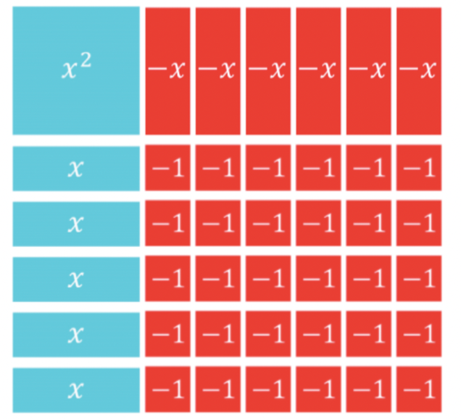
$$x^{2}-x-30$$

- Find the product of $(x-5)(x+7)$. Write the product in standard form.
$$x^{2}+2x-35$$

- A table representing the trinomial $n^{2}-24n+44$ is shown.
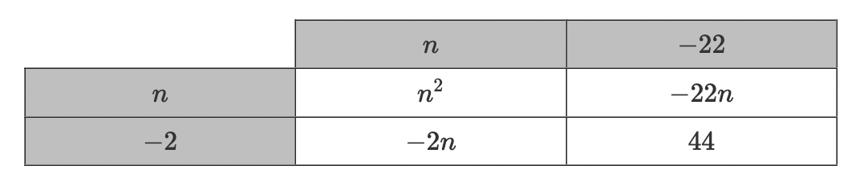
The factors of the trinomial are $(n-22)$ and ___________________.
$$(n-2)$$

